BMS INSTITUTE OF TECHNOLOGY AND MANAGEMENT
(An Autonomous Institute affiliated to VTU, Belagavi, Approved by AICTE New Delhi)
Yelahanka, Bengaluru 560119
Department of Artificial Intelligence and Machine Learning

Mini Project Proposal - BAI506
Academic Year 2026-27
Section and Batch No:  AIML 06/F1 |  | Guide Name:  Dr. Mayuri K P |  | Submission Date:  18-09-2026
Mini Project Title

“An Intelligent Computer Vision System for Plant Disease and Pest Detection Using Deep Learning”
Sl No | USN |  | Name
1 | 1BY24AI079 |  | Manoj A D
2 | 1BY24AI043 |  | G Hrushikesh
3 | 1BY24A1138 |  | Sathvik S S
4 | ITD24A1044 |  | B Niteesh
Project Category |  |  | Computer Vision

Signature of Guide

Initial Project Proposal :`
The proposed project, “AI-Based Plant Disease and Pest Detection Using Computer Vision,” aims to develop a simple and intelligent system that can help farmers identify plant diseases and pests at an early stage. Plant diseases and pest attacks are common problems in agriculture and can seriously affect crop growth, quality, and yield if they are not identified and managed in time. At present, farmers often depend on manual observation or expert advice to identify these problems, which can take time and may not always be easily available. To address this issue, the proposed system will use Computer Vision and Deep Learning to analyze images of plant leaves and other affected parts. Plant images will be collected and preprocessed using Python and OpenCV to make them suitable for analysis. A suitable deep learning model, such as YOLO or CNN, will then be trained to recognize selected plant diseases and pests based on their visible characteristics. When a farmer captures or uploads an image, the system will analyze it and display the detected disease or pest, along with its location and confidence score. The system can also provide basic information, possible causes, and preventive or management suggestions for the detected condition. The main purpose of this project is to create an easy-to-use tool that can support farmers in monitoring plant health without requiring them to have advanced technical knowledge. Through this project, we also aim to demonstrate how Artificial Intelligence, Image Processing, and Computer Vision can be applied to solve a practical problem in agriculture and support faster decision-making, reduce crop losses, and improve overall farm productivity.

- Introduction:
Agriculture is an important sector that depends on healthy crops for better production and food security. Plant diseases and pest attacks are major problems that can reduce crop quality and yield. Identifying these problems at an early stage through manual inspection can be time-consuming and may require expert knowledge. The proposed project, “AI-Based Plant Disease and Pest Detection Using Computer Vision,” aims to provide an automated solution for identifying plant diseases and pests from images. The system uses Computer Vision, Image Processing, and Deep Learning techniques to analyze plant images and detect visible symptoms or pests. By providing quick detection results and basic recommendations, the system can help users monitor plant health more efficiently and support early decision-making in agriculture.
  - Motivation:

- Plant diseases and pest attacks can significantly affect crop quality and agricultural productivity.
- Early detection can help prevent the spread of diseases and reduce crop losses.
- Manual identification of diseases and pests is time-consuming and may require expert knowledge.
- Artificial Intelligence, Computer Vision, and Deep Learning can automate plant health analysis using images.
- The project aims to develop a simple and accessible system for quick detection of plant diseases and pests.
- It provides an opportunity to apply knowledge of Computer Vision, image processing, and machine learning to a real-world agricultural problem.

- Literature Survey:
Researchers have developed various Computer Vision and Deep Learning techniques for detecting plant diseases and pests from images. Jackulin and Murugavalli (2022) reviewed machine learning and deep learning approaches for plant disease detection and reported that deep learning models generally performed better than traditional machine learning methods. Cheng et al. (2017) investigated pest identification in complex backgrounds using CNN and ResNet models, with ResNet-101 achieving 98.67% accuracy, demonstrating the effectiveness of deep learning for pest recognition.
More recent studies have focused on object detection and combined disease-pest recognition. Vilar-Andreu et al. (2024) used YOLOv8 on the IP102 dataset for generalized insect detection and achieved a maximum mAP@0.5 of 96.7%. Karthik et al. (2024) proposed a combined crop disease and pest classification approach using a Swin Transformer and dual-attention multi-scale fusion, achieving 95.68% accuracy on the CCMT dataset.

Recent reviews also highlight that, although deep learning has achieved strong results, challenges remain in real-world agricultural environments, including complex backgrounds, varying lighting, dataset diversity, small disease symptoms, and model generalization. Shoaib et al. (2025) reviewed deep learning methods for both plant disease and pest detection and identified real-world deployment and generalization as continuing challenges. These findings support the need for a practical system that can detect both plant diseases and pests from plant images and provide understandable results to farmers.

SL  NO. | Author and Year | Title | Methodology | Result
1. | Jackulin, C. & Murugavalli, S. (2022) | A comprehensive review on detection of plant disease using machine learning and deep learning approaches | Survey and comparison of ML classifiers (NB, KNN, DT, SVM, RF, MLP, LR) and DL/CNN models (Inception-V4, VGG-16, VGG-19) for plant disease detection; review of image segmentation techniques. | DL models outperform ML models; VGG-16/Inception-V3 achieved precision, F1, CA and AUC of up to ~0.89-0.97, compared to ~0.77-0.93 for ML models (Random Forest, SGD, SVM).
2. | Cheng, X., Zhang, Y., Chen, Y., Wu, Y. & Yue, Y. (2017 | A comprehensive review on detection of plant disease using machine learning and deep learning approaches | Survey and comparison of ML classifiers (NB, KNN, DT, SVM, RF, MLP, LR) and DL/CNN models (Inception-V4, VGG-16, VGG-19) for plant disease detection; review of image segmentation techniques. | DL models outperform ML models; VGG-16/Inception-V3 achieved precision, F1, CA and AUC of up to ~0.89-0.97, compared to ~0.77-0.93 for ML models (Random Forest, SGD, SVM).
3. | Vilar-Andreu, M., Garcia, L., Garcia-Sanchez, A.J., Asorey-Cacheda, R. & Garcia-Haro, J. (2024) | Enhancing precision agriculture pest control: A generalized deep learning approach with YOLOv8-based insect detection | Trained YOLOv8 (n, s, m, l variants) on the IP102 dataset with all 102 insect classes merged into a single generic 'insect' class for crop-agnostic, generalist pest detection | Best mAP@0.5 = 0.967 (model m); best mAP@0.5:0.95 = 0.632 (model l); validation accuracy ~95.5-96.6%; model generalized to new images but struggled at greater distances.
4. | Zhao, S., Wang, H., Liu, T. & Huang, S. (2024) | Integrating multiscale linear attention and focal loss for robust pest classification (MSLA-FL) | Combined lightweight MBConv blocks with a Multi-Scale Linear Attention (MSLA) module (linear-complexity attention + multi-scale convolutions), Focal Loss for class imbalance, and MixUp/CutMix data augmentation. | Achieved 73.23% accuracy on IP102 and 99.47% on D0, outperforming ResNet50, MobileNet, ensemble models and transformers (MaxViT, Swin, ConViT) while using only 34.9 MB and 1.55 ms/image.
5. | Yang, L. & Liu, J. (2025) | A high-accuracy model for agricultural pest detection enhanced with distance pooling and location correction (YOLO-PE) | Improved YOLOv8n by replacing C2f with a DenseNet-pooling based 'DisPool' module, using lightweight 'DySample' upsampling in the neck, and adding an IoU/confidence-weighted 'LC-NMS' location-correction step in post-processing. | mAP@0.5 = 83.8% and mAP@0.5:0.95 = 72.5% on mini-IP102 (24 classes), a 4.5%/4.3% gain over YOLOv8n baseline; remained lightweight (3.25M parameters) and real-time (110 FPS).
6. | Nalwanga, R., Spreeuwers, L., Talavera, E. & Owomugisha, G. (2025) | Multi-crop disease detection in computer vision for resource-constrained farms - a review | Narrative review of the full AI pipeline (data acquisition, preprocessing, model training, deployment) across multiple sensing modalities (RGB, spectral, thermal, fluorescence, LiDAR, IoT) and 20+ public datasets, with focus on multi-crop/intercropped and edge-deployment scenarios. | Identified key gaps: heavy reliance on single-crop RGB datasets, scarcity of multimodal/intercropping datasets, poor cross-region generalization, and lack of real-world edge/offline deployment and farmer usability testing.
7. | Peng, Y. & Wang, Y. (2022)Journal: Ecological Informatics | CNN and transformer framework for insect pest classification | Hybrid CNN-Transformer model: a CNN backbone extracts features, followed by a novel transformer attention-based classification head; used ImageNet-21K pretraining, effective training strategies and data augmentation; evaluated on IP102, D0 and Li's dataset. | Achieved 74.90%/75.58% accuracy on IP102 (224x224/480x480 px), 99.47% on D0, and 97.94% on Li's dataset, outperforming prior CNN-only state-of-the-art with low implementation cost.
8. | Ashurov, A.Y., Al-Gaashani, M.S.A.M., Samee, N.A., Alkanhel, R., Atteia, G., Abdallah, H.A. & Muthanna, M.S.A. (2025)  Journal: Frontiers in Plant Science | Enhancing plant disease detection through deep learning: a Depthwise CNN with squeeze and excitation integration and residual skip connections | Modified depthwise-separable CNN integrated with Squeeze-and-Excitation (SE) attention blocks and improved residual skip connections to strengthen feature representation while lowering computation; trained on a multi-species, multi-disease plant image dataset and tested with online/random images for adaptability. | Achieved 98% classification accuracy and an F1-score of 98.2%, outperforming baseline CNNs while balancing accuracy and computational efficiency.
9. | Krishna, M.S., Machado, P., Otuka, R.I., Yahaya, S.W., Neves dos Santos, F. & Ihianle, I.K. (2025)  Journal: J (MDPI) | Plant Leaf Disease Detection Using Deep Learning: A Multi-Dataset Approach | Fine-tuned EfficientNet-B0, EfficientNet-B3, ResNet50 and DenseNet201 on a combined dataset built from PlantDoc plus newly web-scraped plant images; applied enhanced augmentation (Gaussian noise, flips, rotation, colour jitter) and evaluated within-dataset, cross-dataset and combined-dataset scenarios. | EfficientNet-B3 achieved 73.31% accuracy on PlantDoc alone, 76.77% in cross-dataset testing, and a best 80.19% when trained on the combined PlantDoc + web-sourced dataset, showing dataset diversity most improves real-world generalisation.
10. | Li, D., Xu, Y., Yuan, Z. & Dai, Z. (2024)  Journal: Agriculture (MDPI) | GDnet-IP: Grouped Dropout-Based Convolutional Neural Network for Insect Pest Recognition | Modified Inception-based CNN with a grouped dropout strategy driven by the WeDIV clustering algorithm; replaced ReLU with PReLU and added BatchNorm after each Inception module to improve nonlinear learning and reduce overfitting; tested on 20 insect species (15 pests + 5 beneficial insects). | Cross-validation accuracy improved from 84.68% (baseline) to 92.12% (GDnet-IP), with large gains for hard-to-classify species (e.g., 38%->62% and 47%->93%), and faster training than four conventional CNNs.
11. | Ayan, E. (2023)  Journal: Arabian Journal for Science and Engineering | Genetic algorithm-based hyperparameter optimization for convolutional neural networks in the classification of crop pests | Used a genetic algorithm to optimise hyperparameters of three pretrained CNNs (MobileNetV2, DenseNet121, InceptionResNetV2) via transfer learning; tested on three insect datasets of increasing scale/difficulty: Deng's (10 classes), D0 (40 classes) and IP102 (102 classes). | Achieved state-of-the-art accuracies of 99.89% (D0) and 97.58% (Deng's dataset), and a competitive 71.84% on the large, imbalanced IP102 dataset.
12. | Shoaib, M., Sadeghi-Niaraki, A., Ali, F., Hussain, I. & Khalid, S. (2025)  Journal: Frontiers in Plant Science | Leveraging deep learning for plant disease and pest detection: a comprehensive review and future directions | Comprehensive review of deep learning models (CNN-based, transformer-based and hybrid architectures) used for plant disease/pest image classification, detection and segmentation, covering datasets and challenges such as variability in shape, size, texture, background and lighting. | Synthesises current DL approaches and confirms CNN-based classification networks as the dominant paradigm; identifies persistent real-world deployment and generalisation challenges and outlines future research directions.
13. | Upadhyay, A., Chandel, N.S., Singh, K.P., Chakraborty, S.K., Nandede, B.M., Kumar, M., Subeesh, A., Upendar, K., Salem, A. & Elbeltagi, A. (2025)  Journal: Artificial Intelligence Review | Deep learning and computer vision in plant disease detection: a comprehensive review of techniques, models, and trends in precision agriculture | Systematic review of deep learning and computer vision techniques (standard CNNs, customised/lightweight architectures, transfer learning) applied to plant disease detection, with emphasis on trends in precision agriculture and resource-limited deployment (e.g., mobile/edge devices). | Highlights those customised, lightweight models (e.g., a streamlined DenseNet for mango-leaf disease classification) as particularly effective for resource-limited environments; synthesises trends across techniques, models and datasets in the field.
14. | Wang, S., Xu, D., Liang, H., Bai, Y., Li, X., Zhou, J., Su, C. & Wei, W. (2025)  Journal: Remote Sensing | Advances in Deep Learning Applications for Plant Disease and Pest Detection: A Review | Systematic literature review (182 studies via CNKI and Google Scholar, following a PRISMA-style protocol) of deep learning techniques - image classification, object detection (two-stage and single-stage/YOLO), semantic segmentation, and change detection - for plant disease/pest identification, plus the role of pre-trained large models and transfer learning. | Synthesises reported accuracies across techniques (e.g., transfer-learning models reaching 92-99% on various crop datasets) and identifies key challenges: dataset diversity/scale, model generalisation, small-lesion detection, and the need for lightweight edge deployment.
15. | Karthik, R., Ajay, A., Bisht, A.S., Illakiya, T. & Suganthi, K. (2024) | A deep learning approach for crop disease and pest classification using Swin transformer and dual-attention multi-scale fusion network | Dual-track architecture fusing a Swin Transformer branch (global features) with a custom CNN DAMFN branch (MSA, TSCA, TC blocks for local multi-scalefeatures), combined via Triplet Attention and classified with cross-entropy loss. | Achieved 95.68% accuracy on the CCMT dataset (22 classes, 4 crops), outperforming SqueezeNet, EfficientNet, VGG, AlexNet, ShuffleNet, ResNet and DenseNet (91.55%-94.51%) with only 6M parameters.

  - Limitations of Existing System:
- Many existing systems work well only with clear and high-quality images.
- Performance may decrease under different lighting conditions.
- Complex backgrounds can make it difficult to detect diseases and pests accurately.
- Some systems focus only on plant disease detection or pest detection, not both.
- Detecting small or partially visible pests can be challenging.
- Existing models may support only a limited number of crops and disease/pest categories.
- Some systems require high computational resources for accurate detection.
- Many existing solutions are designed for research environments and may not be simple or user-friendly for farmers.

2.2 Outcome of the Literature Survey:
Based on the literature survey, existing systems have limitations in detecting plant diseases and pests under real-world conditions. To address these gaps, the proposed system will combine plant disease and pest detection using Computer Vision and Deep Learning techniques. The system will be trained using diverse plant images with different backgrounds and lighting conditions and will use models such as YOLO/CNN for accurate detection. It will provide clear results, including the detected disease or pest, its location, and confidence score, through a simple and user-friendly interface.

- Problem Statement :

Plant diseases and pest attacks are major challenges in agriculture that can reduce crop quality and yield. Traditional identification methods rely on manual inspection, which can be time-consuming and may require expert knowledge. Therefore, there is a need for an automated and efficient solution to identify these problems at an early stage. This mini project proposes an AI-Based Plant Disease and Pest Detection System using Computer Vision, which analyzes plant images using Deep Learning techniques such as YOLO/CNN to detect and identify common plant diseases and pests. The system aims to provide quick and clear detection results, helping users monitor plant health and take appropriate preventive measures.

  - Objectives:
- To collect and preprocess plant images to identify visual characteristics associated with selected diseases and pests.
- To develop a deep learning-based detection model for identifying selected plant diseases and pests from plant images(CNN, YOLOv8).
- To detect and localize affected regions in plant images and display the detected disease or pest with its confidence score.
- To provide relevant information and preventive measures for the detected plant disease or pest to support timely crop health management.
- Proposed Methodology:
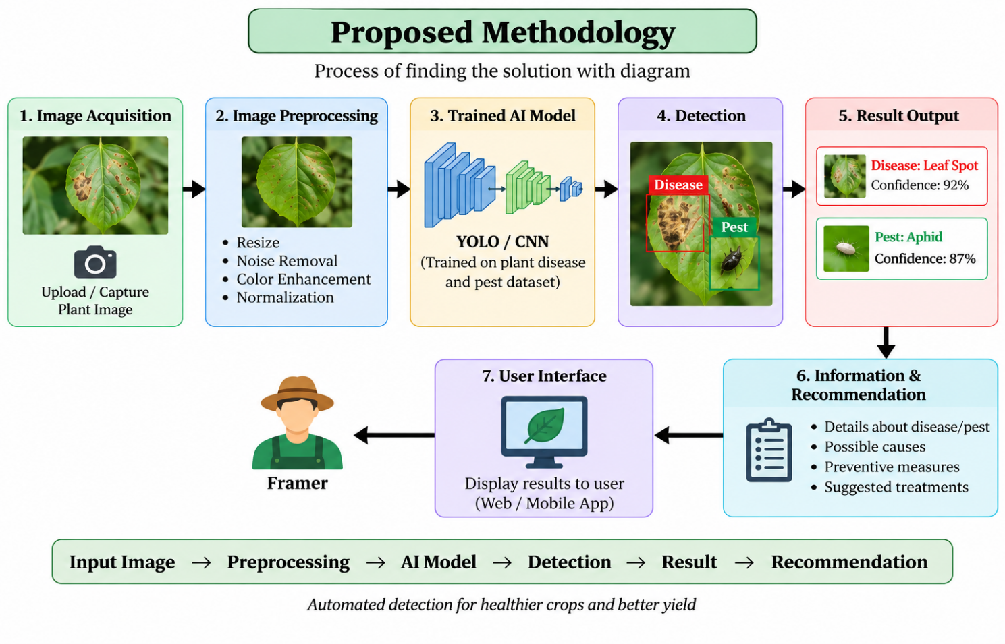
- Image Acquisition – Collect plant images using a camera or upload images through the system.
- Image Preprocessing – Resize, normalize, and enhance the images to improve detection accuracy.
- Dataset Preparation – Collect and label images of healthy plants, diseased plants, and plants affected by pests.
- Model Training – Train a YOLO/CNN Deep Learning model using the prepared dataset.
- Disease Detection – Analyze the input image and identify the presence and type of plant disease.
- Pest Detection – Detect and identify visible pests affecting the plant.
- Result Generation – Display the detected disease or pest along with its confidence score and location.
- Recommendation – Provide basic information and preventive measures related to the detected disease or pest.

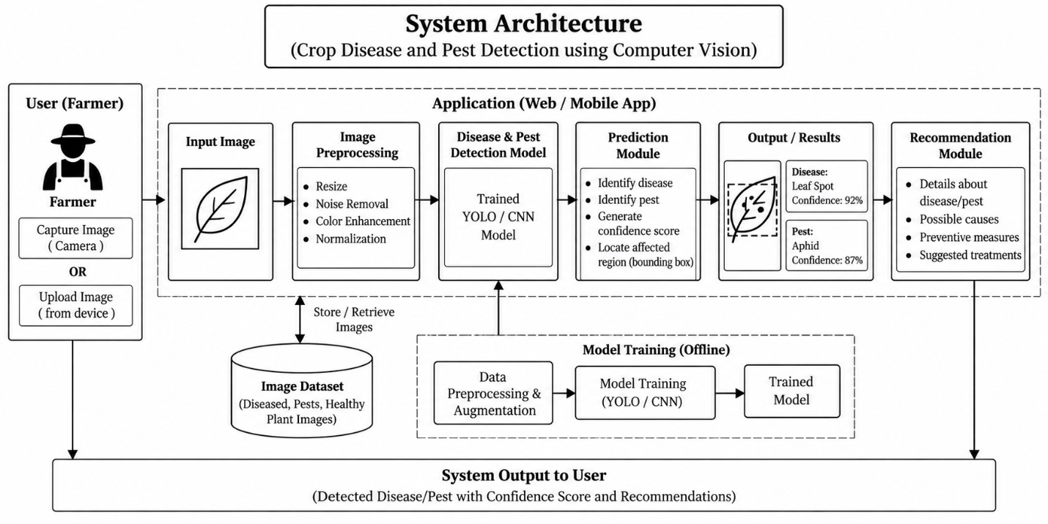
- System Requirement Specifications (Functional & Non-Functional):
5.1 Functional Requirements
- The system should allow the farmer to upload or capture a plant image.
- The system should preprocess the uploaded image before analysis.
- The system should detect and identify plant diseases from the image.
- The system should detect and identify pests present on the plant.
- The system should display the detected disease or pest name.
- The system should display the confidence score and detection location.
- The system should provide basic information and preventive recommendations for the detected condition.
5.2 Non-Functional Requirements
- Accuracy: The system should provide reliable disease and pest detection.
- Performance: The system should process images and provide results within a reasonable time.
- Usability: The interface should be simple and easy for farmers to use.
- Reliability: The system should produce consistent results for similar input images.
- Scalability: The system should allow additional crops, diseases, and pests to be added in the future.
- Security: User-uploaded images and data should be handled securely.
- Maintainability: The software and AI model should be easy to update and maintain.

5.3 User Requirements
- The farmer should be able to upload or capture a plant image easily.
- The system should provide quick and understandable detection results.
- The farmer should be able to identify the detected plant disease or pest.
- The system should display the confidence score and detected area in the image.
- The system should provide basic information about the detected disease or pest.
- The system should provide simple preventive or management recommendations.
- The interface should be simple, clear, and easy to use for farmers.
- The system should support clear images captured using a mobile phone or camera.
5.5 Software Requirements
- Operating System: Windows 10/11 or Linux
- Programming Language: Python
- Computer Vision: OpenCV
- Deep Learning Framework: TensorFlow / PyTorch
- Object Detection Model: YOLO
- Data Processing: NumPy, Pandas
- Model Training: Google Colab / Jupyter Notebook
- Development Environment: Visual Studio Code
- User Interface: Streamlit
- Web Browser: Google Chrome / Microsoft Edge
- Dataset: Plant disease and pest image dataset
- Version Control: Git and GitHub (optional)

References:
[1] C. Jackulin and S. Murugavalli, “A comprehensive review on detection of plant disease using machine learning and deep learning approaches,” Measurement: Sensors, vol. 24, Art. no. 100441, 2022.
[2] X. Cheng, Y. Zhang, Y. Chen, Y. Wu, and Y. Yue, “Pest identification via deep residual learning in complex background,” 2017.
[3] M. Vilar-Andreu, L. Garcia, A. J. Garcia-Sanchez, R. Asorey-Cacheda, and J. Garcia-Haro, “Enhancing precision agriculture pest control: A generalized deep learning approach with YOLOv8-based insect detection,” 2024.
[4] S. Zhao, H. Wang, T. Liu, and S. Huang, “Integrating multiscale linear attention and focal loss for robust pest classification,” 2024.
[5] R. Karthik, A. Ajay, A. S. Bisht, T. Illakiya, and K. Suganthi, “A deep learning approach for crop disease and pest classification using Swin transformer and dual-attention multi-scale fusion,” 2024.
[6] L. Yang and J. Liu, “A high-accuracy model for agricultural pest detection enhanced with distance pooling and location correction (YOLO-PE),” 2025.
[7] R. Nalwanga, L. Spreeuwers, E. Talavera, and G. Owomugisha, “Multi-crop disease detection in computer vision for resource-constrained farms: A review,” 2025.
[8] Y. Peng and Y. Wang, “CNN and transformer framework for insect pest classification,” Ecological Informatics, s2022.
[9] A. Y. Ashurov, M. S. A. M. Al-Gaashani, N. A. Samee, R. Alkanhel, G. Atteia, H. A. Abdallah, and M. S. A. Muthanna, “Enhancing plant disease detection through deep learning: A Depthwise CNN with squeeze and excitation integration and residual skip connections,” Frontiers in Plant Science, 2025.
[10] M. S. Krishna, P. Machado, R. I. Otuka, S. W. Yahaya, F. Neves dos Santos, and I. K. Ihianle, “Plant leaf disease detection using deep learning: A multi-dataset approach,” Journal (MDPI), 2025.
[11] D. Li, Y. Xu, Z. Yuan, and Z. Dai, “GDnet-IP: Grouped dropout-based convolutional neural network for insect pest recognition,” Agriculture, 2024.
[12] E. Ayan, “Genetic algorithm-based hyperparameter optimization for convolutional neural networks in the classification of crop pests,” Arabian Journal for Science and Engineering, 2023.
[13] M. Shoaib, A. Sadeghi-Niaraki, F. Ali, I. Hussain, and S. Khalid, “Leveraging deep learning for plant disease and pest detection: A comprehensive review and future directions,” Frontiers in Plant Science, 2025.
[14] A. Upadhyay, N. S. Chandel, K. P. Singh, S. K. Chakraborty, B. M. Nandede, M. Kumar, A. Subeesh, K. Upendar, A. Salem, and A. Elbeltagi, “Deep learning and computer vision in plant disease detection: A comprehensive review of techniques, models, and trends in precision agriculture,” Artificial Intelligence Review, 2025.
[15] S. Wang, D. Xu, H. Liang, Y. Bai, X. Li, J. Zhou, C. Su, and W. Wei, “Advances in deep learning applications for plant disease and pest detection: A review,” Remote Sensing, 2025.
[16]. A.padhyay, N. S. Chandel, K. P. Singh, S. K. Chakraborty, B. M. Nandede, M. Kumar, A. Subeesh, K. Upendar, A. Salem, and A. Elbeltagi, “Deep learning and computer vision in plant disease detection: A comprehensive review of techniques, models, and trends in precision agriculture,” Artificial Intelligence Review, vol. 58, Art. no. 92, 2025.
[17] C. Jackulin and S. Murugavalli, “A comprehensive review on detection of plant disease using machine learning and deep learning approaches,” Measurement: Sensors, vol. 24, Art. no. 100441, 2022.
[18] X. Wu, C. Zhan, Y.-K. Lai, M.-M. Cheng, and J. Yang, “IP102: A Large-Scale Benchmark Dataset for Insect Pest Recognition,” Proceedings of the IEEE/CVF Conference on Computer.
[19] Q. Dong, L. Sun, T. Han, M. Cai, and C. Gao, “PestLite: A Novel YOLO-Based Deep Learning Technique for Crop Pest Detection,” Agriculture, vol. 14, no. 2, p. 228, 2024.
[20] W. Zhang, H. Huang, Y. Sun, and X. Wu, “AgriPest-YOLO: A rapid light-trap agricultural pest detection method based on deep learning,” Frontiers in Plant Science, vol. 13, Art. no. 1079384, 2022

